Introduction:

Simultaneous Localization and Mapping (SLAM) has been a popular topic in robotics research for a long time. Several feature-based methods have been proposed to solve this problem, such as EKF, SEIF, ESEIF, which base on the Kalman Filter approach; FAST-SLAM, which bases on the exact Rao-Blackwellized Particle Filter approach and Pose-Graph SLAM, which formulates the SLAM problem as a nonlinear optimization but can only be used offline.

For online SLAM algorithms, complexity and robustness are two crucial aspects to be considered. Algorithms of high complexity may impose strict restriction on the maximum number of features to be located as well as the requirement of expensive computational amount and memory, while those of low robustness may result in inconsistent estimation or divergence, which leads to catastrophic consequences such as collision.

EKF-SLAM is regarded as the golden standard for the solution of SLAM problem as it preserves consistency over long trajectory by remembering the correlation between robot and landmarks. Besides, convergence property has been proved that the estimation of the uncertainty decreases monotonically and converges to a lower bound as the number of observations increases. [1]

However, the cubic complexity of updating the covariance matrix using observation prevents the online application of EKF-SLAM to environment of more than thousands of landmarks. This computational limitation can be overcome in two ways. One is by the development of algorithms of much lower complexity such as SEIF, ESEIF and FAST-SLAM, while all these ‘pure’ SLAM methods have some drawbacks with respect to consistency, linearization error and loop closing. The other way is by sub-map approaches, which creates local maps and fuses them recursively to generate a consistent global map. The latter approach allows the application of two different algorithms for the local and global maps respectively.

In this paper, a hybrid sub-map based approach for the SLAM problem is presented. The key idea is to use FAST-SLAM as a front-end to generate local maps and fuses them to the EKF-SLAM back-ended global map. [2]

The subsequent sections are arranged as follow: In Section 2, previous works are reviewed and the key contribution of this paper is summarized. In Section 3, technical details of the implementation are presented. Focus has been put on the transformation of particle representation to a single Gaussian distribution, covariance propagation, map fusion and data association. In Section 4, simulation results on the simulator and the Victoria Park data set are presented. The performance of the hybrid method concerning complexity and consistency compared with EKF-SLAM and FAST-SLAM is investigated and possible modifications are discussed. In Section 5, conclusions are drawn.

Review of Related Previous works:

The theoretical background of sub-map building, matching and fusion with the global map was presented in Tardós et.al.[3], which serves as a foundation of this work. A compressed filter approach was implemented by Guivant et.al. [4], which essentially applied the sub-map approach on a EKF front and back-end algorithm for efficient SLAM. This significantly reduced the complexity, while it was subject to linearization error and prone to wrong data association due to the EKF front-end. The idea of Hybrid SLAM using FAST-SLAM front-end and EKF-SLAM back-end was proposed by Brooks and Bailey [2], which acclaimed a superior performance over both EKF and FAST-SLAM. Nevertheless, the technical details were not presented with sufficient details.

Our work presented in this paper formulates the missing technical details as well as addresses important corner cases and adopt an adaptive scheme to determine the fusion time. The advantages of Hybrid SLAM can be summarized as follow:

1. Linearization errors are eliminated by the FAST-SLAM front-end.
2. Correlation and consistency are preserved by the EKF-SLAM back-end.
3. Complexity is drastically reduced due to the much fewer Kalman updates and much fewer particles required because of the limited size of the local map.
4. Robustness for data association and loop closure is significantly increased due to the increased number of matched features between local and global maps.

Simulation Results and Discussion:

Consistency:

One of the important criterions for robust SLAM algorithms is the capability of preserving consistency. Loss of consistency can result in failure of data association, loop closure and even more severe consequences such as collision if the results of SLAM are to be used for planning.

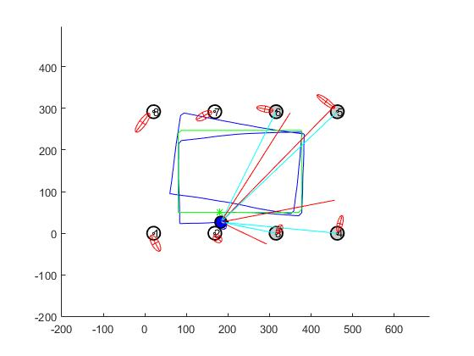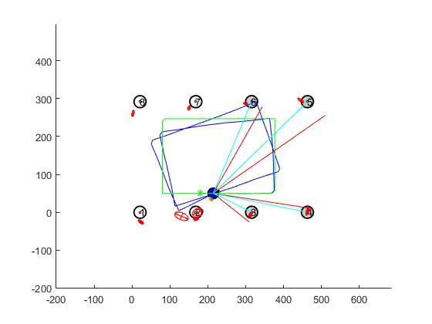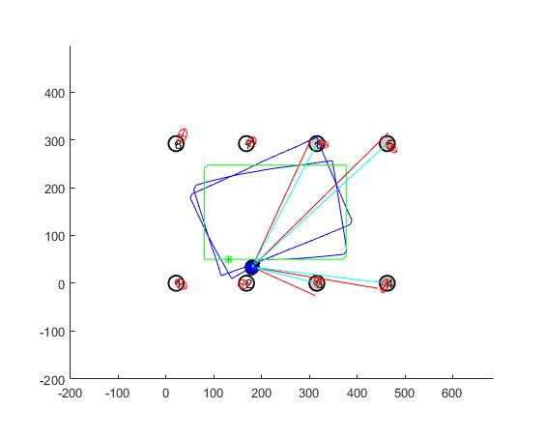

Fig.1 Consistency of the resulting map generated by EKF-SLAM (Left), FAST-SLAM (Middle, 50 particles) and Hybrid-SLAM (Right, 50 particles, fusion every 10 steps)

Fig.1 shows the SLAM results by EKF, FAST and Hybrid-SLAM after 200 time steps. All of the three results have reached a steady state, i.e., the mean and covariance of the landmarks does not significantly change with time any more. The three sigma ellipsoids generated by EKF and Hybrid-SLAM are larger than those generated by FAST-SLAM, which indicates that the effect of particle degeneracy in general leads to over-confidence. This problem can be well handled by Hybrid-SLAM because the local map generated by FAST-SLAM front-end is transformed into a Gaussian representation and fused to the global map every several time steps before the particles degenerate severely. The cross correlation between the robot and landmarks are preserved by taking the variance of the estimation of landmarks by each particles into consideration.

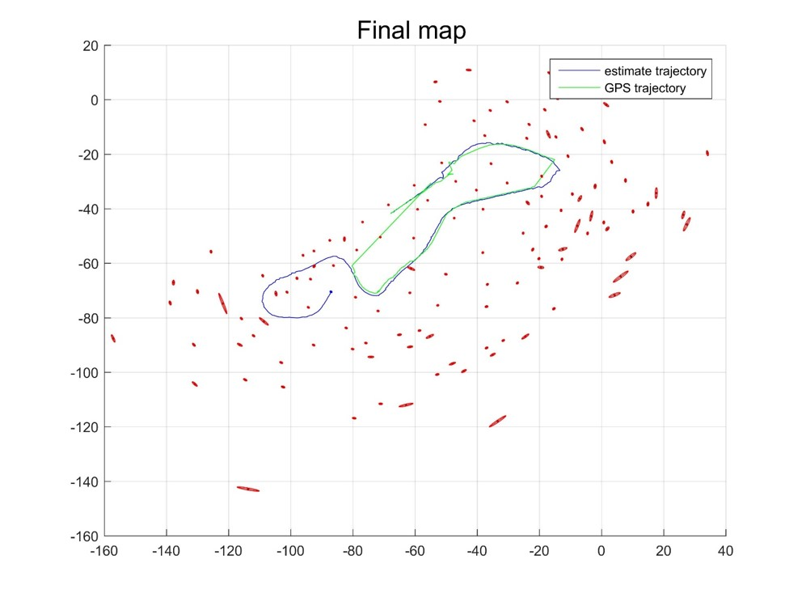

Fig.2 Hybrid-SLAM solution to the Victoria Park data set

Fig.2 shows the SLAM solution by Hybrid-SLAM on the Victoria Park data set. It is very similar to that by EKF-SLAM, indicating nice consistency preserving property of the hybrid algorithm.

Time evolution of determinant…..

Moreover, Hybrid-SLAM also inherits the advantage of FAST-SLAM that no linearization is made in the prediction step. Therefore, Hybrid-SLAM outperforms EKF-SLAM where nonlinearity is significant such as a sharp turn. Also noted that the aspect ratios of the ellipsoids generated by Hybrid-SLAM are smaller than those generated by EKF-SLAM. This is because that the front-end makes no linearization to initialize the landmarks using observation, which results in a banana shaped estimation for landmarks uncertainty. While linearization error is also a source of over-confidence, the effect is much less significant than that of diversity loss. Nonetheless, large linearization error can result in large uncertainty of the current state estimation and make it prone to wrong data association.

Data Association:

Bad data association decisions can be made with high possibility when the uncertainty caused by linearization error becomes large. Wrong data association can make the state estimation deviate from the ground truth and even cause filter divergence when it happens during loop closure. This problem cannot be solved by JCBB if a spurious observation occurs without the true feature being observed. Fig.3 illustrates the typical scenario where a sharp turn results in large transient uncertainty of the robot pose and consequently wrong data association caused by inaccurate sensing.



Fig.3 Evolution of robot pose uncertainty (Left) and wrong data association caused by spurious observation

Illustration of the effect of the linearization error on data association

Possible remedies can be rejecting observation if it is hard to make the data association decision or delaying the association decision and using the current observation to update future state. In either case, the state estimation process is delayed which is undesirable. Besides, it is not straightforward to update the current state using a previous observation in either EKF or FAST-SLAM frames, which forces the filter to make hard data association decisions. This problem can be solved by Hybrid-SLAM by adopting an adaptive scheme to determine the time for map fusion. When the data association becomes hard due to large uncertainty, the map fusion process is delayed and the observations are used to update the local map without any loss of information. Wrong data association in the local map can be overturned by the voting mechanism and particles that make bad data association have a large possibility of being eliminated by resampling. Map fusion is made when the uncertainty of the local robot pose and landmarks decreases below a certain level. As the size of the local map increases, the number of matched pairings between the local and global maps also increases. This also boosts the robustness of JCBB as the possibility of incorporating spurious observation becomes exponentially small with the increasing number of matched pairings.

Complexity:

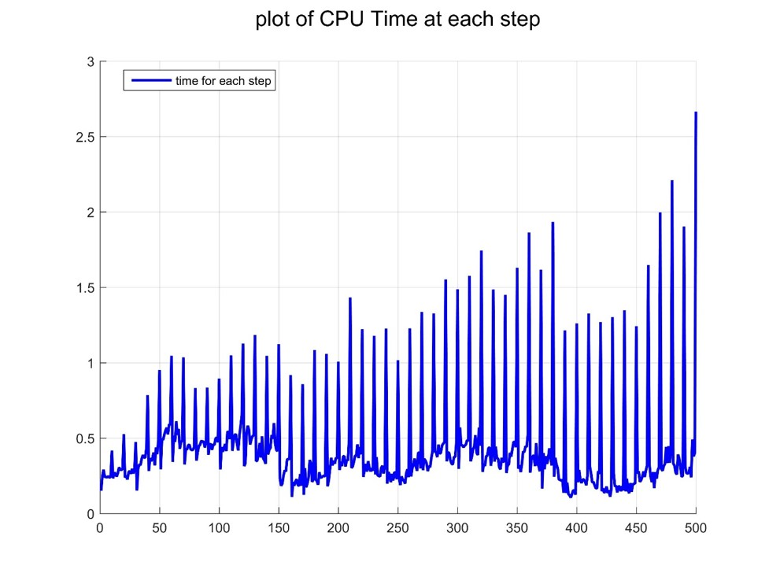

Fig.2 Complexity of Hybrid-SLAM

Fig.2 shows the computational time of Hybrid-SLAM on the Victoria Park data set. The spikes appearing every 10 time steps are caused by the map fusion, which includes the transformation from particle representation, data association and the modified EKF update. The height of the spikes increases over time as the associated complexity increases with the number of landmarks in the global map. However, except for the map fusion, the average complexity does not increase with time as shown in the figure. This is because the size of the local map is limited which mostly depends on the time steps between which two successive map fusion process takes place. A small number of time steps between successive map fusion allows a choice of fewer number of particles in the local map since the size of the local map will be small and degeneracy will not be a problem; while a large number of time steps between successive map fusion can significantly save the computational complexity of the map fusion since the total number of map fusion process is reduced by a factor of the number of local map time steps.

Reference:

[1] Dissanayake, M. W. M. G., et al. "A solution to the simultaneous localization and map building (SLAM) problem." *Robotics and Automation, IEEE Transactions on* 17.3 (2001): 229-241.

[2] Brooks, Alex, and Tim Bailey. "HybridSLAM: Combining FastSLAM and EKF-SLAM for reliable mapping." *Algorithmic Foundation of Robotics VIII*. Springer Berlin Heidelberg, 2009. 647-661.

[3] Tardós, Juan D., et al. "Robust mapping and localization in indoor environments using sonar data." *The International Journal of Robotics Research* 21.4 (2002): 311-330.

[4] Guivant, Jose E., and Eduardo Mario Nebot. "Optimization of the simultaneous localization and map-building algorithm for real-time implementation." *Robotics and Automation, IEEE Transactions on* 17.3 (2001): 242-257.